**Doctor-X v.1.0**

**doctor-x Screen design**

RECORD OF CHANGE

|  |  |  |  |  |
| --- | --- | --- | --- | --- |
| Effective Date | Change Items | A* , M , D | Change Description | New Vesion |
| First Create | All new | A+ | Khanh was add all description screen design | V1.0 |
|  |  |  |  |  |
|  |  |  |  |  |
|  |  |  |  |  |

1 INTRODUCTION

* 1. Purpose

This application allows users to search for a doctor within the scanned user's phone radius.

Documentation for the programmer building the program.

* 1. Definitions, Acronyms and Abbreviations

Now we don’t have any thing in here

|  |  |  |
| --- | --- | --- |
| Definitions | Description | Comment |
|  |  |  |
|  |  |  |
|  |  |  |
|  |  |  |
|  |  |  |

* 1. References

|  |  |
| --- | --- |
| Document Number | Title |
| Non number | FPT Screen Design |
|  |  |
|  |  |
|  |  |
|  |  |

1.4 Overview

This application allows users to search for a doctor within the scanned .

1. SCREEN FLOW

|  |  |  |
| --- | --- | --- |
| No | Screen Name | Description |
| 1 | Login screen | After the user finishes typing in all steps, click on button to proceed to login  If the user does not have an account, click on the link will go to the registration screen |
| 2 | Registration screen | After the user finishes typing in all steps, click on button to proceed to create account |
| 3 | Patient Main Screen | Used to call an ambulance  Contain health tips.  Used to look for doctors in the scan radius of the user's phone.  Used to look for hospitals in the scan radius of the user's phone.  Remind patients taking medication. |
| 4 | Doctor main screen | Allow doctor find patient in the scan radius of the user's phone. |
| 5 | Appointment of Doctor | ListView provides a list of patients. Allows the doctor to accept or make an appointment |
| 6 | History Doctor | - ListView provides a list of patients who have been treated. |
| 7 | Search doctor screen | Screen allows the patient to look for a doctor according to the conditions chosen by the patient. |
| 8 | Search Result Doctors Screen | The screen will list the doctors the phone scans in the user's radius and their current location. |
| 9 | Inspection | Screen showing full information, position of doctor, distance from doctor. |
| 10 | Detail Doctor | Screen show about information: Name of doctor, Specialty, Address, Rating and Review |
| 11 | Setting Profile | Interface helps users enter information into the fields. After the user completes entering all the steps, click the button to continue configuration. |
| 12 | Book-Emergency | Screen helps patients find doctors and hospitals in case of an emergency |
| 13 | Search doctor | Screen Show location of doctor with patient  Show list near hospitals |
| 14 | Directions to the hospital | Screen helps guide the patient to the nearest hospital |
| 15 | My Doctor of Scren My Pitient | Give the user a list of doctors and list their favorite doctors |
| 16 | …. | ……. |
|  |  |  |

* 1. All screen in application

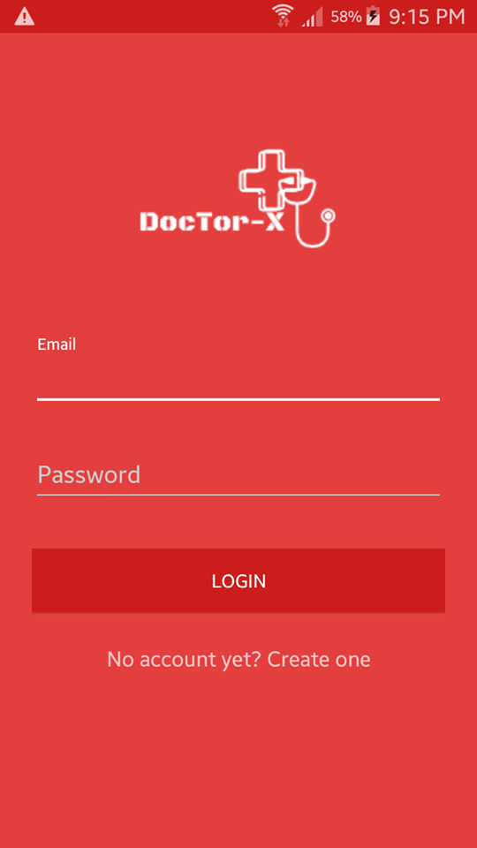

Hình 1 : Sceen Login

|  |  |  |  |
| --- | --- | --- | --- |
| **No** | **Component**  **Name** | **Format** | **Note** |
| 1 | **Login screen has 2 field for input, 1 button, 1 link :**   * 1 field for input email * 1 field for input password * 1 button for login * 1 link connect to registration screen if user hasn’t account. | **1 field for input email** :   * Use TextView : * Text : Email * Use EditText : * TextSize: 30dp * Color :#FFFFFF   **1 field for input password :**   * Use TextView : * Text : Email * Use EditText : * TextSize: 30dp * Color :#FFFFFF   **1 button for login :**   * Use Buttom : * Text : Login * TextSize :30dp Color :#FFFFFF * Background :#FF0000 * Gravity="center".   **1 Link :**  Use TextView :   * Text : No account yet? Create one * TextSize : 30dp * Color :#FFFFFF * Gravity="center" |  |

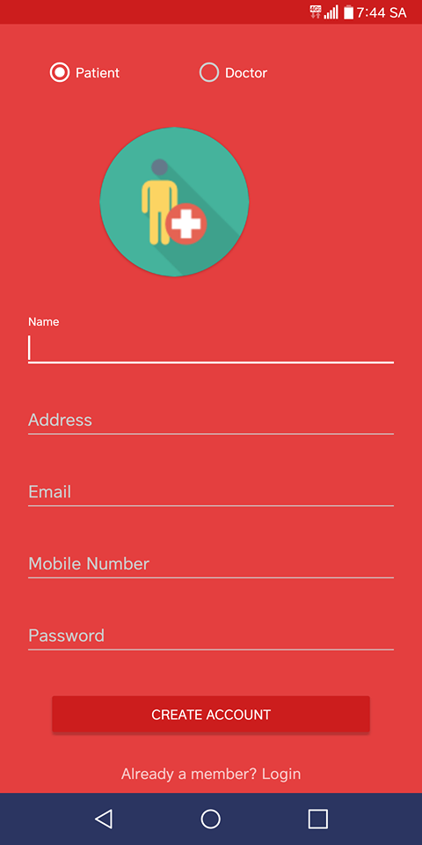

Hình 2: Registration screen

|  |  |  |  |
| --- | --- | --- | --- |
| **No** | **Component**  **Name** | **Format** | **Note** |
| 2 | Registration screen has 5 field for input , 2 radio button, 1 link :   * 1 Image Avatar * 1 field for input full name of user * 1 field for input address * 1 field for input email * 1 field mobile number * 1 field password * 2 radio buttom * 1 buttom | **1 Image Avatar** :   * Use ImageView : * Attach the path to the image. * Gravity="center".   **1 field for input full name of user :**   * Use TextView : * Text : Name * Use EditText : * TextSize: 30dp * Color :#FFFFFF   **1 field for input address :**   * Use TextView : * Text : Name * Use EditText : * TextSize: 30dp * Color :#FFFFFF   **1 field for input email :**   * Use TextView : * Text : Name * Use EditText : * TextSize: 30dp * Color :#FFFFFF   **1 field mobile number :**   * Use TextView : * Text : Name * Use EditText : * TextSize: 30dp * Color :#FFFFFF   **1 field password :**   * Use TextView : * Text : Name * Use EditText : * TextSize: 30dp * Color :#FFFFFF   **2Radio Buttom :**   * Use RadioButtom * 1-RadioButtom :Patient * 1-RadioButtom :Doctor   **1 field Re-enter Password :**   * Use TextView : * Text : Name * Use EditText : * TextSize: 30dp * Color :#FFFFFF   **1 buttom Create Account :**   * Use Buttom : * Text : Login * TextSize :30dp Color :#FFFFFF * Background :#FF0000 * Gravity="center". |  |

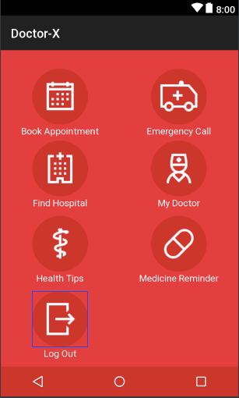

Hình 3 :Main screen of patient

|  |  |  |  |
| --- | --- | --- | --- |
| **No** | **Component**  **Name** | **Format** | **Note** |
| 3 | **Patient main screen has 6 buttons and navigation bar:**   * Book appiontment * Emergency Call * Find hospital * My Doctor * Health tips * Medicine Reminder * Log out | **1 Book Appiontment :**   * Use ImageButtom * Width :”fill_parent” * Height:”fill_parent” * color: #FFFFFF * Use TextView   text : Book Appiontment  **1 Emergrncy Call:**   * Use ImageButtom * Width :”fill_parent” * Height:”fill_parent” * color: #FFFFFF * Use TextView   text : Emergency Call  **1 Find hospital:**   * Use ImageButtom * Width :”fill_parent” * Height:”fill_parent” * color: #FFFFFF * Use TextView   text : Find hospital  **1 My DocTor:**   * Use ImageButtom * Width :”fill_parent” * Height:”fill_parent” * color: #FFFFFF * Use TextView   text : My Doctor  **1 Health tips :**   * Use ImageButtom * Width :”fill_parent” * Height:”fill_parent” * color: #FFFFFF * Use TextView   text : Health Tips  **1 Medicine Reminder**   * Use ImageButtom * Width :”fill_parent” * Height:”fill_parent” * color: #FFFFFF * Use TextView   text : Medicine Reminder  **1 Log out:**   * Use ImageButtom * Width :”fill_parent” * Height:”fill_parent” * color: #FFFFFF * Use TextView   text : Log out | -Move to book appointment screen.  - Move to call ambulance screen.  - Move to find hospital screen  - Move to My Doctor screen  - Move to health tips screen  - Move to Medicine Reminder screen  -Scroll to find the registration screen |

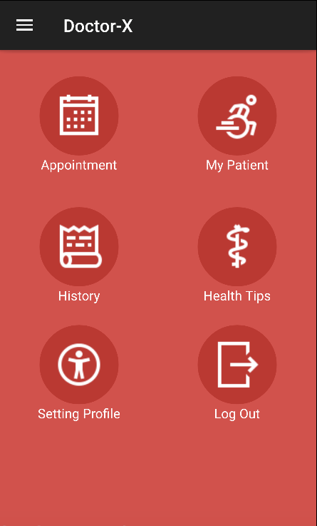

Hình 4 :Doctor main screen

|  |  |  |  |
| --- | --- | --- | --- |
| **No** | **Component**  **Name** | **Format** | **Note** |
| 4 | **Doctor main screen has 6 button , 1 Menu:**  - 1 Menu  - Appointment  - My patient  - History  - Health Tips  - Setting Profile  - Log out | **1 Appiontment :**   * Use ImageButtom * Width :”fill_parent” * Height:”fill_parent” * color: #FFFFFF * Use TextView * text : Appiontment   **1 My patient:**   * Use ImageButtom * Width :”fill_parent” * Height:”fill_parent” * color: #FFFFFF * Use TextView * text : My Patient   **1 History:**   * Use ImageButtom * Width :”fill_parent” * Height:”fill_parent” * color: #FFFFFF * Use TextView * text : History   **1 Health Tips:**   * Use ImageButtom * Width :”fill_parent” * Height:”fill_parent” * color: #FFFFFF * Use TextView * text :Health Tips   **1 Setting Profile :**   * Use ImageButtom * Width :”fill_parent” * Height:”fill_parent” * color: #FFFFFF * Use TextView * text : Setting Profile   **1 Log out:**   * Use ImageButtom * Width :”fill_parent” * Height:”fill_parent” * color: #FFFFFF * Use TextView * text : Logout | -Move to book appointment screen.  -Move to book My patient screen.  -Move to History screen.  - Move to Health Tips screen.  - Move to Setting Profile screen.  - Move to Login screen |

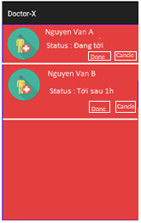

Hình 5: Appointment

|  |  |  |  |
| --- | --- | --- | --- |
| **No** | **Component**  **Name** | **Format** | **Note** |
| 5 | Screen has 1 section:  - List Patient | **List Patient:**   * Use ListView * ImageView * TextView * 1 Buttom :   Name:Done  Color:#FFFFFF  gravity="left".   * 1Buttom :   Name : Cancel  Color:#FFFFFF  gravity="left". | - ListView provides a list of patients. Allows the doctor to accept or make an appointment |

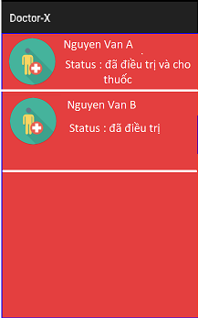

Hình 6 :History Doctor

|  |  |  |  |
| --- | --- | --- | --- |
| **No** | **Component**  **Name** | **Format** | **Note** |
| 6 | Screen has 1 section:  - List Patient | **List Patient:**   * Use ListView * ImageView * TextView | - ListView provides a list of patients who have been treated. |

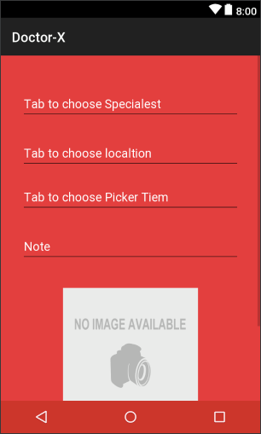 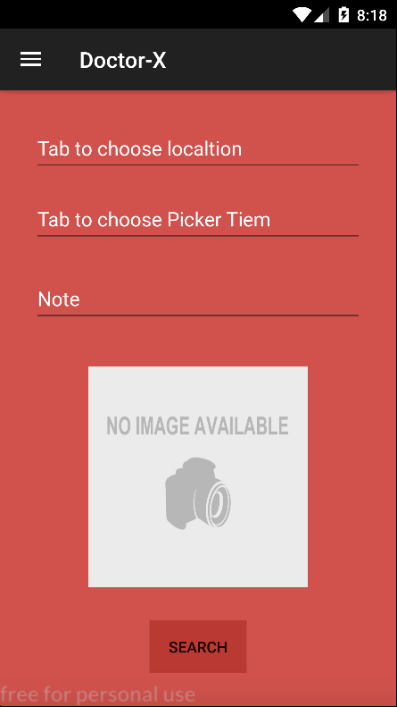

Hình 7 : Search doctor

|  |  |  |  |
| --- | --- | --- | --- |
| **No** | **Component**  **Name** | **Format** | **Note** |
| 7 | Search doctor screen has 4 fields and 2 button:   * Tab to choose Specialest * Tab to choose localtion * Tab to choose Picker Item * Note * ImageView Picture description * Button Search | **Tab to choose Specialest :**   * Use EditText : * Name : Tab to choose Specialest * textSize : 25dp * color : #FFFFFF   **Tab to choose localtion :**   * Use EditText : * Name : Tab to choose localtion * textSize : 25dp * color : #FFFFFF   **Tab to choose Picker Item :**   * Use EditText : * Name : Tab to choose Picker Item * textSize : 25dp * color : #FFFFFF   **Note :**   * Use EditText : * Name : Note * textSize : 25dp * color : #FFFFFF   **ImageView Picture description :**   * Use ImageView : Access to camera phone.   **Button Search :**   * Use Buttom : * Text : Login * TextSize :30dp Color :#FFFFFF * Background :#FF0000 * Gravity="center". | -Patients will choose the specialty they want to choose  - User position will show in maps.  - Current comment status of patient.  -The user will select the image that is description of their case .  - Move to search result screen. |

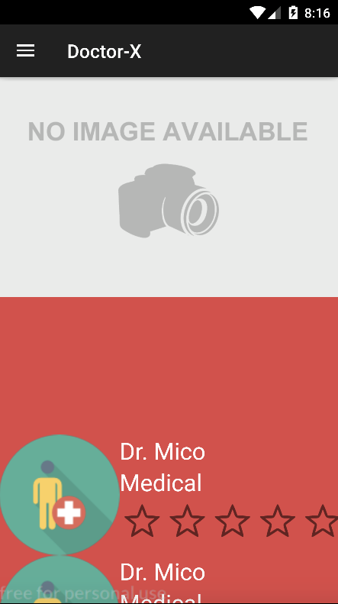

Hình 8 :Search result doctors

|  |  |  |  |
| --- | --- | --- | --- |
| **No** | **Component**  **Name** | **Format** | **Note** |
| 8 | **Search result doctors has 2 section:**   * Maps and positon of doctors in maps * Information of doctors * Navigation bar | **Maps and positon of doctors in maps :**   * Use Google Map.   **Information of doctors :**   * Use ImageView : * TextView : name Doctor * TextView : medical * TextSize : 25dp * ImageButtom : src: Move to the image storage place for the patient to evaluate.   **Navigation bar :** | - User will search doctors in line with their medical needs  - User will watch detail information of doctors their choose.  - Move to user-selectable functions |

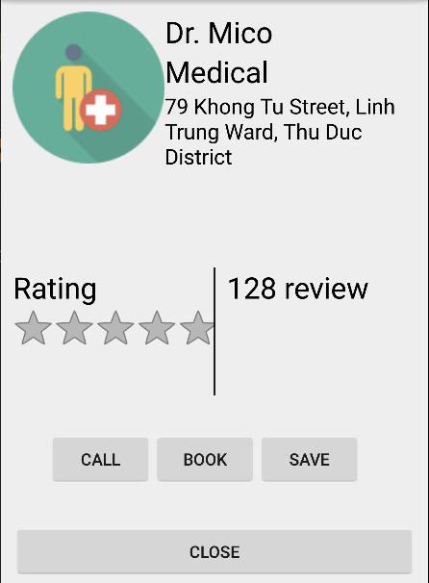

Hình 9 : Inspection

|  |  |  |  |
| --- | --- | --- | --- |
| **No** | **Component**  **Name** | **Format** | **Note** |
| 9 | Screen has 1 section show imformation of doctor, 4 button:   * Call * Book * Save * Close | **Information of doctors :**   * Use ImageView : * TextView : name Doctor * TextView : medical * TextSize : 25dp * ImageButtom : src: Move to the image storage place for the patient to evaluate.   **Buttom Call :**   * Use Buttom * Name : Call * TextSize : 25dp * Color :#000000 * Background : * #CCCCCC   **Buttom Book :**   * Use Buttom * Name : Book * TextSize : 25dp * Color :#000000 * Background : * #CCCCCC   **Buttom Save :**   * Use Buttom * Name : Save * TextSize : 25dp * Color :#000000 * Background : * #CCCCCC   **Buttom Close :**   * Use Buttom * Name : Close * TextSize : 25dp * Color :#000000 * Background : * #CCCCCC | - Help the patient see the doctor's details: evaluation, view.  - Move to call screen of user’s phone.  - Move to appointment screen.  - Information of doctor will be saved.  - Moved to Search result doctor screen |

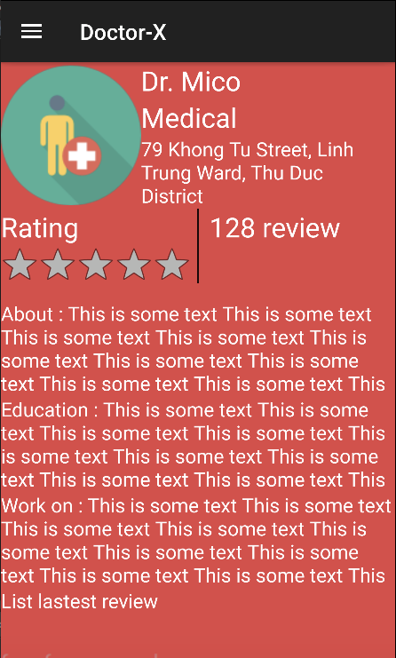

Hình 10 : Detail Doctor

|  |  |  |  |
| --- | --- | --- | --- |
| **No** | **Component**  **Name** | **Format** | **Note** |
| 10 | **Screen has 1 section show imformation of doctor :**   * Navigation bar * Information of doctors : | **Navigation bar :**  **Information of doctors :**   * Use ImageView : * TextView : name Doctor * TextView : medical * TextSize : 25dp * ImageButtom : src: Move to the image storage place for the patient to evaluate. * Use TextView : * Name : About…. * textSize :25dp | - Move to user-selectable functions  - Help the patient see the doctor's details: evaluation, view. |

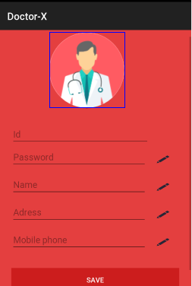

Hình 11: Setting Profile

|  |  |  |  |
| --- | --- | --- | --- |
| **No** | **Component**  **Name** | **Format** | **Note** |
| 11 | Doctor information setting screen has 5 fields and 1 button  - 1 field for ID  - 1 filed password  - 1 field for name  - 1 field for address  - 1 fileld mobile phone  - 1 buttom | **1 field for ID :**   * Use EditText : * Name hint : ID * textSize : 25dp   **1 field for Password:**   * Use EditText : * Name hint : Password * textSize : 25dp   **1 Image Buttom :**   * Use Image Buttom : A path to the place containing image image.   **1 field for Name:**   * Use EditText : * Name hint : Name * textSize : 25dp   **1 Image Buttom :**   * Use Image Buttom : A path to the place containing image image.   **1 field for Address:**   * Use EditText : * Name hint : Address * textSize : 25dp   **1 Image Buttom :**   * Use Image Buttom : A path to the place containing image image.   **1 field for Mobile Phone:**   * Use EditText : * Name hint : Address * textSize : 25dp   **1 Image Buttom :**   * Use Image Buttom : A path to the place containing image image.   **1 Buttom Save :**   * Use Buttom : * Name : Save * textSize :25dp | - User provides ID to save personal information  - User provides Password to save personal information.  - Let the user edit the password  - User provides Name to save personal information.  - Let the user edit the Name  - User provides Address to save personal information.  - Let the user edit the Address  - User provides Mobile Phone to save personal information.  - Let the user edit the Mobile phone  - Press save button to update personal information |

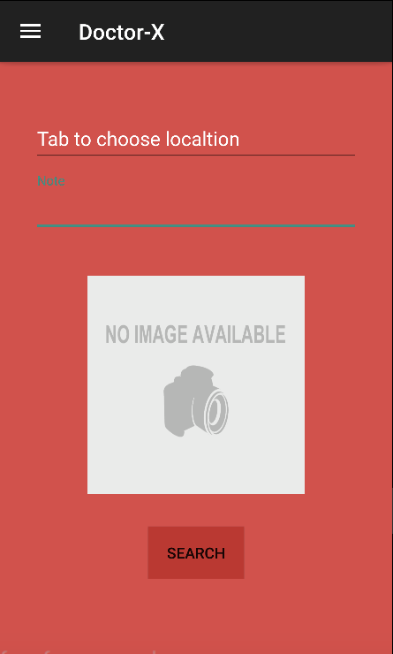

Hình 12 : Book-Emergency

|  |  |  |  |
| --- | --- | --- | --- |
| **No** | **Component**  **Name** | **Format** | **Note** |
| 12 | Search doctor screen has 2 fields and 1 button:   * Tab to choose localtion * Note * ImageView Picture description * Button Search | **Tab to choose localtion :**   * Use EditText : * Name : Tab to choose localtion * textSize : 25dp * color : #FFFFFF   **Note :**   * Use EditText : * Name : Note * textSize : 25dp * color : #FFFFFF   **ImageView Picture description :**   * Use ImageView : Access to camera phone.   **Button Search :**   * Use Buttom : * Text : Login * TextSize :30dp * Color :#FFFFFF * Background :#FF0000 * Gravity="center". | - User position will show in maps.  - Current comment status of patient.  -The user will select the image that is description of their case .  - Move to search result screen. |

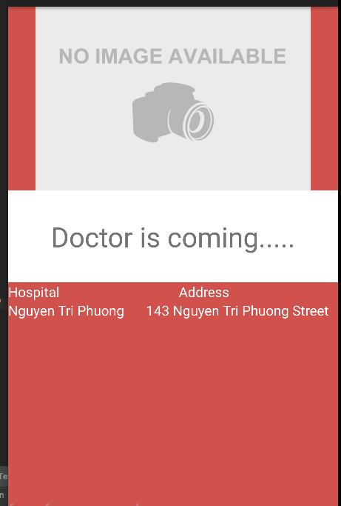

Hình 13 : Search doctor

|  |  |  |  |
| --- | --- | --- | --- |
| **No** | **Component**  **Name** | **Format** | **Note** |
| 13 | **Screen has 3 section:**  - Maps  - Load list Doctor  - List hospitals | **Maps :**  Use google map provided by google.  **Load List Doctor :**   * Use textView : * Name : Doctor is coming… * textSize : 25dp * color :#DDDDD * Gravity="center".   **List Hospitals :**   * Use TextView * Textsize :25dp * Color: #FFFFFF | - User watch information of doctor in maps.  - Screen Let users view the list of doctors.  - Screen Let users view the list of hospitals |

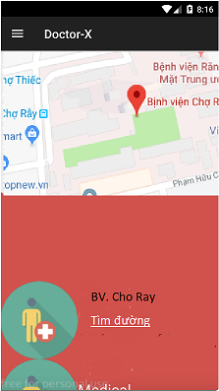

Hình 14 : Directions to the hospital

|  |  |  |  |
| --- | --- | --- | --- |
| **No** | **Component**  **Name** | **Format** | **Note** |
| 14 | **Screen has 2 section:**  - Maps  - List Hospital | **Maps :**  Use google map provided by google.  **List Hospital :**   * Use ListView: * ImageView * TextView * Link | - User watch information of Hospital in maps.  - ListView Give the user the closest hospital and directions to the hospital. |

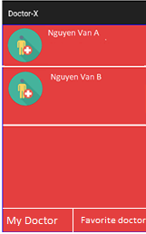

Hình 15 : My Doctor of Scren My Pitient

|  |  |  |  |
| --- | --- | --- | --- |
| **No** | **Component**  **Name** | **Format** | **Note** |
| 15 | **Screen has 2 section:**   * List Doctor * TabView | **List Hospital :**   * Use ListView: * ImageView * TextView   **TabView :**   * 1 tabView :   MyDoctor   * 1tabView:   Favorite doctor | - ListView Provides users with a list of doctors.  TabView : MyDoctor  - My list of doctors will be selected will display the list of doctors nearest.  1tabView:  Favorite doctor  Tab my favorite doctor displays a list of favorite doctors |

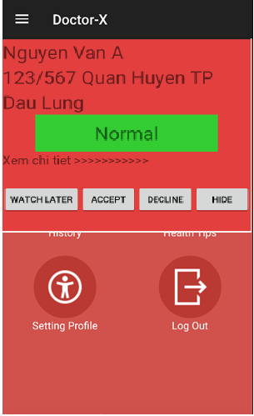

Hình 16 .....

|  |  |  |  |
| --- | --- | --- | --- |
| **No** | **Component**  **Name** | **Format** | **Note** |
| 16 | **Screen has 2 section:**   * 2 TextView * 4 Buttom * Link | **TextView :**   * Use 3 TextView: * Color :#111111 * TextSize : 25dp * Gravity="left ".   **TextView :**   * UseTextView: * Name : Normal * Background : #00FF33   **Link :**   * Use TextView: * Name: Xem Chi Tiết>>>>> * Color:#111111   **Buttom :Watch Latter**   * Use Buttom : * Name : Watch Later * Color: #111111 * Backround :#EEEEEE   **Buttom :Accept**   * Use Buttom : * Name : Accept * Color: #111111 * Backround :#EEEEEE   **Buttom :Decline**   * Use Buttom : * Name : Decline * Color: #111111 * Backround :#EEEEEE   **Buttom :Hide**   * Use Buttom : * Name : Hide * Color: #111111 * Backround :#EEEEEE | - Help the doctor know the name, address and medical condition of the patient.  - Background Text Help with patient's condition: emergency or common illness.  - The link helps the doctor see the patient's medical details.  -Watch Latter.  -Accept .  -Deciline.  -Hide |